Name : ibraheem Qasim

Sap id : 42896

Section : BSCS 4

Course : Software engineering

**Assignment No 1**

**Protoype of a mobile application**

The prototype of mobile application is :

Food odering application

**Requirments :**

This application is developed for a multiple user and the requirments of this application are

* Start
* Main menu
* Conform your odder
* Check out

The user interface is very easy to implement

**Screenshot :**

This is the start up of the application

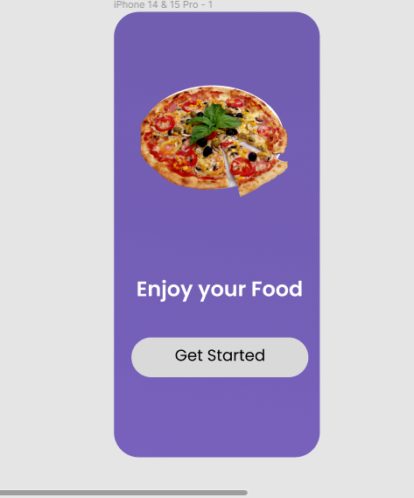

The next step is the main menu

**Screenshot:**

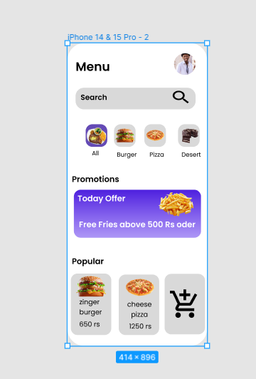

In this interface the user will able to odder his/her favourite type of foods and snacks ,the userface is very friendly.

The third step is conformation of the food item.

**Screenshot:**

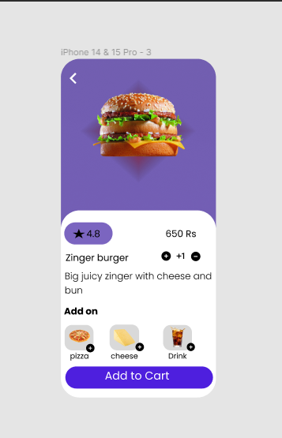

In this menu the user will able to conform his oder or even further he will be able to add some other things if he likes.

The next and the last step of this application is checkout menu in which user will able to check out his oder

**Screenshot**

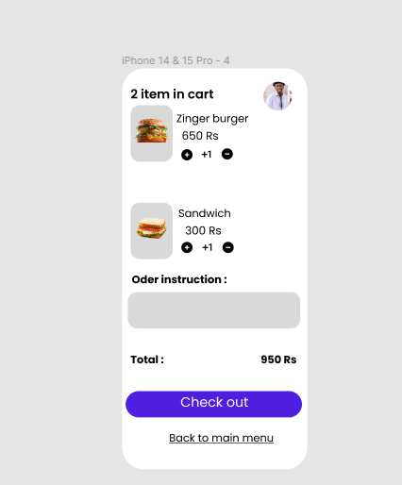

In this step the user will also able to add his instruction to oder in which he will be able to give instruction that how he will like to take his food etc.

This is the final look of the application

